Project Design Phase-II
Data Flow Diagram & User Stories

Date | 15 July 2026
Team ID
Project Name | SHOPEZ – Full Stack E-Commerce Application using MERN Stack
Maximum Marks | 4 Marks

Data Flow Diagrams:
A Data Flow Diagram (DFD) is a traditional visual representation of the information flows within a system. A neat and clear DFD can depict the right amount of the system requirement graphically. It shows how data enters and leaves the system, what changes the information, and where data is stored.

Example: (Simplified)
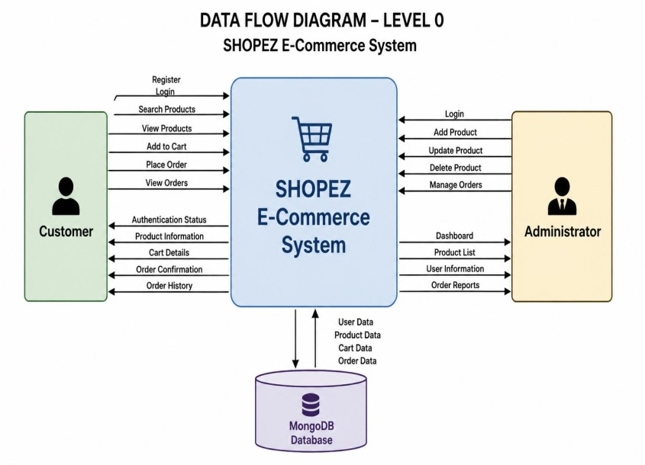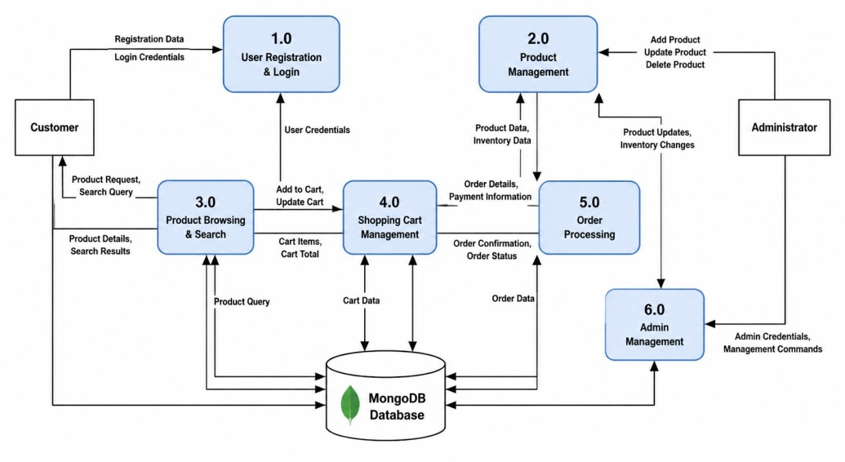
User Stories
Use the below template to list all the user stories for the product.
User Type | Functional Requirement (Epic) | User Story No. | User Story / Task | Acceptance Criteria | Priority | Release
Customer | Registration | USN-1 | As a customer, I can register using my name, email, and password. | User account is created successfully. | High | Sprint-1
Customer | Login | USN-2 | As a customer, I can log in using my registered email and password. | User is redirected to the home page. | High | Sprint-1
Customer | Product Browsing | USN-3 | As a customer, I can browse available products. | Products are displayed correctly. | High | Sprint-1
Customer | Product Search | USN-4 | As a customer, I can search for products by name. | Matching products are displayed. | High | Sprint-1
Customer | Product Details | USN-5 | As a customer, I can view detailed information about a product. | Product details page opens correctly. | High | Sprint-1
Customer | Shopping Cart | USN-6 | As a customer, I can add products to my shopping cart. | Selected product is added successfully. | High | Sprint-1
Customer | Cart Management | USN-7 | As a customer, I can update or remove products from my cart. | Cart updates correctly. | High | Sprint-1
Customer | Checkout | USN-8 | As a customer, I can place an order by entering shipping details. | Order is placed successfully. | High | Sprint-2
Customer | Order History | USN-9 | As a customer, I can view my previous orders. | Order history is displayed correctly. | Medium | Sprint-2
Customer | Logout | USN-10 | As a customer, I can securely log out of the application. | User session ends successfully. | High | Sprint-2
Administrator | Admin Login | USN-11 | As an administrator, I can log in to the admin dashboard. | Admin dashboard opens successfully. | High | Sprint-1
Administrator | Product Management | USN-12 | As an administrator, I can add new products. | Product is saved in the database. | High | Sprint-1
Administrator | Product Management | USN-13 | As an administrator, I can update existing products. | Updated product information is saved. | High | Sprint-2
Administrator | Product Management | USN-14 | As an administrator, I can delete products. | Product is removed successfully. | High | Sprint-2
Administrator | Order Management | USN-15 | As an administrator, I can view and manage customer orders. | Order status is updated successfully. | High | Sprint-2
Administrator | User Management | USN-16 | As an administrator, I can view registered users. | User list is displayed correctly. | Medium | Sprint-2

